

VILNIUS UNIVERSITY
ŠIAULIAI ACADEMY
BACHELOR PROGRAMME SOFTWARE ENGINEERING

Computer networks laboratory work No. 2

Student : Hanna Asiadouskaya
Lecturer: dr. Nerijus Ramanauskas

Šiauliai, 2024

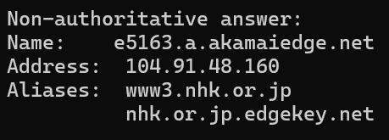
- www.vu.lt canonical name = www11001.vu.lt
www11001.vu.lt canonical name = web9waf.vu.lt

- 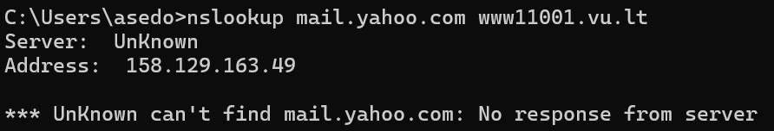
- They are sent by UDP
- DNS Query destination port: 53
DNS Response source port: 53
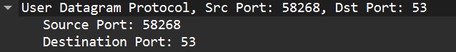
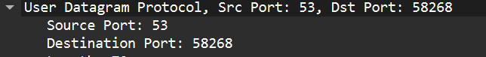
- The DNS query message was sent to my local DNS server

- Standard query type A, no answers
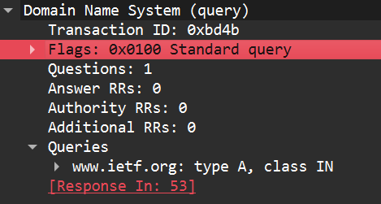
- Two answers, containing information about host
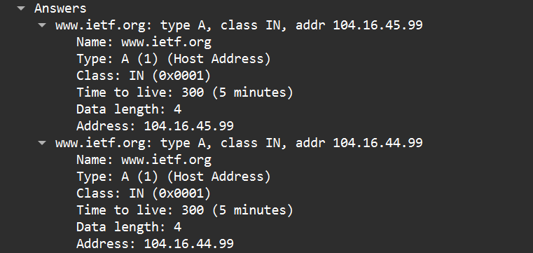
- Destination address is the address of the host, which was received before.
- No
- DNS Query destination port: 53
DNS Response source port: 53
- The DNS query message was sent to my local DNS server
- Standard query type A, no answers
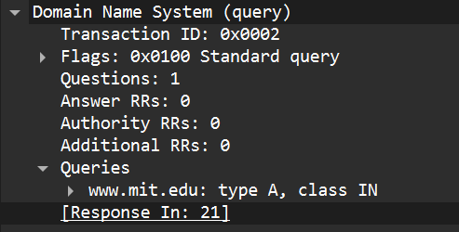

- 3 answers provided, containing host addresses and names

- 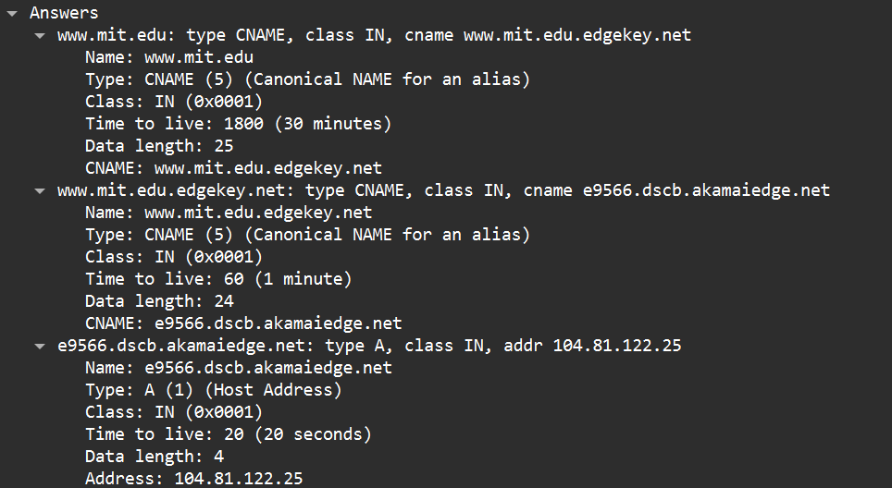

- 192.168.0.1, which the same as my local DNS server

- Standard query type A, without answers

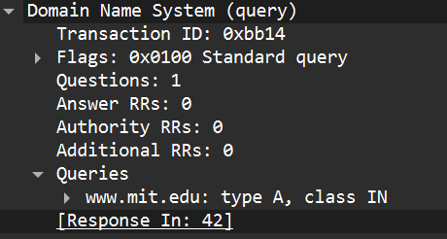
- Response provides two MIT nameservers, as well as their addresses
- 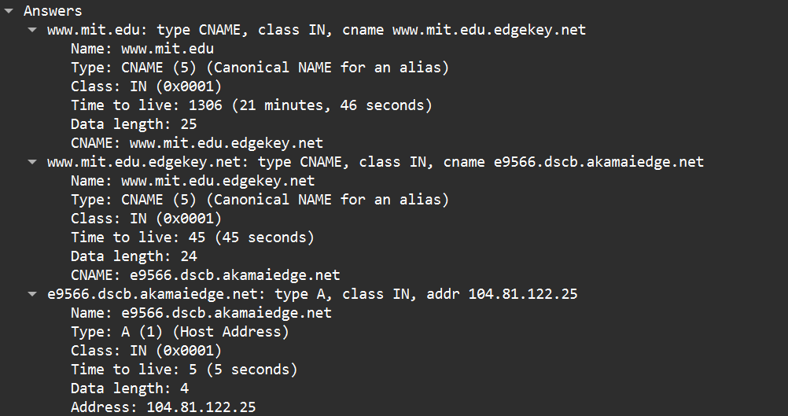
- The query messages are sent to 18.0.72.3, which is an address of bitsy.mit.edu
- Standard query type A, without answers
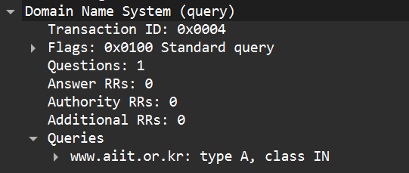
- The host had not responded, I received a timeout error: 